**BECE 2010**

**MATHEMATICS 2**

## ESSAY

## 1 hour

[60 marks]

*Answer* **four** *questions* **only** *from this section*

*All working must be clearly shown.*

*The use of calculators is* **not** *allowed*

*Marks will* **not** *be awarded for correct answers without corresponding working.*

*All questions carry equal marks*

1. (a) Factorize: *(m + n)(2x – y) – x(m + n)*

(b) A and B are subsets of a universal set

U = {1,2,3,4,5,6,7,8,9,10,11,12,13,14,15,16,17,18}

Such that A = {even numbers} and B = {multiples of 3}

(i) List the elements of the sets A, B, (A∩B), (AUB) and (AUB)′

(ii) Illustrate the information in (i) on a Venn diagram

(c) Find the values of *x* and *y* in the vector equation



1. (a) Find the sum of 2,483**.**65, 701**.**532 and 102**.**7, giving your answer to one decimal place.

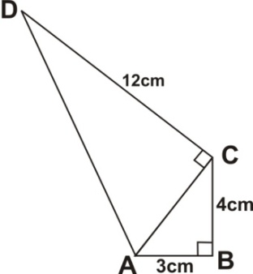

(b) In the quadrilateral ABCD above, |AB| = 3 cm, |BC| = 4 cm, |CD| = 12 cm and angle ABC = 90°. Calculate:

(i) the perimeter of ABCD

(ii) the area of ABCD

1. (a) Evaluate: , leaving your answer in standard form.

(b) Kwame rode a bicycle for a distance of *x* km and walked for another ½ hour at a rate of 6 km/hour. If Kwame covered a total distance of 10 km, find the distance *x* he covered by bicycle.

(c) A rectangular tank of length 22 cm, width 9 cm and height 16 cm is filled with water.

The water is poured into a cylindrical container of radius 6 cm.

Calculate the :

(i) volume of the rectangular tank

(ii) depth of water in the cylindrical container.

[Take π = 22/7]

1. (a) Simplify: 

(b) The area of a trapezium is 31.5 cm2. If the parallel sides are of lengths 7.3 cm and 5.3 cm, calculate the perpendicular distance between them.

(c) The marks scored by four students in a Mathematics test are as follows:

Esi - 92

Seth - 85

Mary - 65

Efe - *x*

(i) Write down an expression for the mean (average) of the marks.

(ii) If the mean is less than 80, write a linear inequality for the information

(iii) Find the possible marks Efe scored in the test. Represent your answer on the number line.

1. (a) Solve: 

(b) Using a scale of 2 cm to 1 unit on both axes, draw two perpendicular lines OX and OY on a graph sheet for the x – axis from -5 to 5 and the y – axis from -6 to 6.

(i) Plot the points A(2, 3) and B(-3, 4) and join them with a long straight line

(ii) Plot on the same graph sheet, the points C(4, 2) and D(-2, -3) and join them with a long straight line to meet the line through AB

(iii) Measure the angle between the lines through AB and CD.

(iv) Find the coordinates of the point at which the lines through AB and CD meet.

1. The table below shows the frequency distribution of the number of letters in the surnames of some students in a school.

|  |  |  |  |  |  |  |  |
| --- | --- | --- | --- | --- | --- | --- | --- |
| **No. of letters** | 4 | 5 | 6 | 7 | 8 | 9 | 10 |
| **No. of students** | 7 | 3 | 2 | 8 | 5 | 3 | 1 |

(a) From the distribution, determine

(i) the mode

(ii) the mean

(b) If a student is selected at random, find the probability that his/ her name will contain more than 7 letters.

(c) Draw a bar chart for the distribution.

**MATHEMATICS 1**

## OBJECTIVE TEST

## 1 hour

1. Which of the following sets is well defined?

A. {Man, Kofi, Red, 14}

B. {Ink, Mango, Green, Nail}

C. {Car, Road, Glass, Book}

D. {Seth, Mary, Jacob, Evelyn}

1. If set B is a subset of set A, then

A) sets A and B have the same number of elements

B) some members of set B can be found in set A

C) no member of set B is in set A

D) all the members of set B are in set A

1. The leastcommon multiple (LCM) of 16, 30 and 36 is

A) 3 B) 6 C) 240 D) 720

1. The sum of 5 and x divided by 4 is equal to 3.25. Find the value of x.

A) 8 B) 7 C) 2¼ D) 

1. The numbers 32, 33, 34, …, …, 42 form a sequence in base 5.

Find the missing numbers

A) 35, 36 B) 30, 31 C) 40, 41 D) 31, 41

1. Write down all the integers in the set A = {-10, -4, 0, ¼, 2½, 45, 100}

A. {-10, -4, 0, 45, 100}

B. {-10, - 4}

C. {0, 45, 100}

D. {¼, 2½}

1. Find the total cost of 25 pens and 75 books if each pen costs GH¢ 0.20 and each book costs GH¢ 0.30.

A) GH¢22.50 B) GH¢23.50 C) GH¢27.50 D) GH¢50.00

1. Simplify - 27 + 18 – (10 – 14) – (-2)

A) – 3 B) – 7 C) – 11 D) – 35

1. Arrange the following numbers from the lowest to the highest: 0.5, 3, -5, 0.

A) 0, 0.5, -5, 3 B) 0, -5, 0.5, 3 C) -5, 0, 0.5, 3 D) -5, 0.5, 0, 3

1. Find howmany pieces of cloth 5½ m long that can be cut from a roll of cloth 121 m long.

A) 665½ B) 115½ C) 66 D) 22

1. Find the value of 124.3 + 0.275 + 74.06, correcting your answer to one decimal place.

A) 198.6 B) 198.7 C) 892.0 D) 892.4

1. Esi and Kwasi are 12 and 8 years old respectively. They share 60 mangoes in the ratio of their ages. How many mangoes does Esi get?

A) 42 B) 40 C) 36 D) 18

1. It takes 6 students 1 hour to sweep their school compound. How long will it take 15 students to sweep the same compound?

A) 24 minutes B) 12 minutes C) 3 hours D) 2 hours

1. A housing agent makes a commission of GH¢ 103,500 when he sells a house for GH¢ 690,000. Calculate the percentage of his commission.

A) 15.0% B) 10.0% C) 7.5% D) 5.0%

1. A simple interest of GH¢ 37,500.00 is earned on an amount of GH¢ 500,000.00 for 3 years. Find the rate of interest per annum.

A) 20.0% B) 10.0% C) 5.0% D) 2.5%

1. Simplify: 

A) 3*x*3*y*7 B) 3*x*2*y*7 C) 3*x*3*y*4 D) 3*xy*

1. The scores of 10 students in anexamination are given as follows:

45, 12, 75, 81, 54, 51, 24, 67, 19 and 39.

What is the median of the scores?

A) 39 B) 48 C) 51 D) 54

1. A pie chart is to be drawn from the data in the following table:

|  |  |
| --- | --- |
| Cassava | 20% |
| Yam | 17% |
| Plantain | 28% |
| Maize | 35% |

What will be the value of the angle of the sector for maize?

A) 126.0° B) 100.8° C) 72.0° D) 61.2°

1. Eighteen cards are numbered from 11 to 29. If one card is chosen at random, what is the probability that it contains the digit 2?

A)  B)  C)  D) 

1. Find the value of *x*, if .

A) 24 B) 20 C) 19 D) 16

1. Factorize: xy + 5x + 2y + 10

A. (x + 5)(2y + 10)

B. (x + 2)(y + 10)

C. (x + 5)(y + 2)

D. (x + 2)(y + 5)

1. If x ∈ {2, 3, 4, 5}, find the truth set of 2x + 1 < 8

A. {2,3,4} B. {2,3} C. {3,4} D. {4,5}

1. Solve the inequality: 7x – (10x + 3) ≥ - 9

A) x ≥ 2 B) x ≤ 4 C) x ≥ 4 D) x ≤ 2

1. Find the rule of the mapping:

1 2 3 4 5 … *x*

7 11 15 19 23 … *y*

A) *x*→4*x*-3 B) *x*→3-4*x* C) *x*→4*x*+3 D) *x*→4*x*+5

1. Find the circumference of a circle whose area is equal to 64 π cm2.

A) 32 π cm2 B) 16 π cm2 C) 8 π cm2 D) 4 π cm2

1. Which of the following geometric figures is the plane shape of a cube?

A) Circle

B) Rectangle

C) Square

D) Triangle

1. How many lines of symmetry has a rectangle?

A) 4 B) 3 C) 2 D) 1

1. A rectangular box has length 20 cm, width 6 cm and height 4 cm. Find how many cubes of side 2 cm that will fit into the box.

A) 120 B) 60 C) 30 D) 15

1. The interior angle of a regular polygon is 120°. How many sides has this polygon?

A) 3 B) 4 C) 5 D) 6

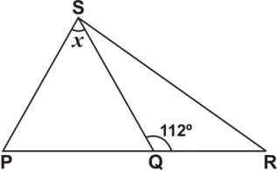

In the diagram above, length of PS = length of SQ and angle SQR = 112°. Find the value of *x*.

A) 68° B) 56° C) 46° D) 44°

1. **XYZ** is a right-angled triangle with length of sides as shown.

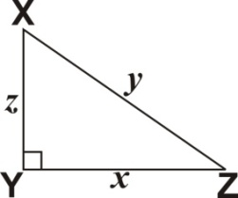

Which of the following equations gives the value of ***z***2?

A) ***z***2 = (***x***2 + ***y***2)

B) ***z***2 = (***x*** – ***y***)

C) ***z***2 = (***y***2 – ***x***2)

D) ***z***2 = (***x***2 – ***y***2)

1. Express 7 min. 30 sec. as a percentage of 1 hour.

A) 2.5% B) 7.5% C) 11.7% D) 12.5%

1. The point (4,5) is translated to the point (3,1). What is the translation vector?

A.  B.  C.  D. 

1. In the diagram below, triangle QRT is the enlargement of QST.

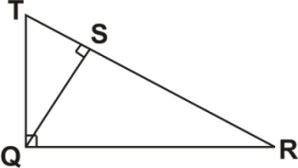

Which side of triangle QRT corresponds to side QT of triangle QST?

A) TS B) TR C) QR D) SR

**H′**

**12 cm**

**20 cm**

**G′**

**E′**

**F′**

**Fig. I**

**Fig. II**

**F**

**H**

**5 cm**

**E**

**G**

**Not drawn to scale**

In the diagrams above Fig. I is an enlargement of Fig. II.

Find the side EF of Fig. II

A) 20 cm B) 5 cm C) 4 cm D) 3 cm

1. Express 4037 in standard form

A) 4.037 × 10-4

B) 4.037 × 10-3

C) 4.037 × 103

D) 4.037 × 104

1. Which of the following angles can be constructed by using the arcs at point C in the diagram below?

A) 30° B) 45° C) 60° D) 75°

**O**

**A**

**B**

**C**

1. Given that vector **a** = $\left(\begin{aligned}-5 \\ 12\end{aligned}\right)$ and **b** = $\left(\begin{aligned}10x \\ 12\end{aligned}\right)$ find the value of *x* if **a** = **b**.

A) -2 B) - ½ C) ½ D) 2

**A**

**40°**

**B**

**Not drawn to scale**

In the diagramabove, the bearing of point **B** from **A** is

A) 340° B) 220° C) 140° D) 50°

1. Ama is 9 years older than Kwame. If Kwame is 18 years old, find the ratio of the age of Kwame to that of Ama.

A) 3 : 2 B) 1 : 3 C) 2 : 3 D) 2 : 1

**MATHEMATICS 1**

## OBJECTIVE TEST

SOLUTIONS

1. D. {Seth, Mary, Jacob, Evelyn}
2. D) all the members of set B are in set A
3. D) 720
4. A) 8
5. C) 40, 41
6. A. {-10, -4, 0, 45, 100}
7. C) GH¢27.50
8. A) – 3
9. C) -5, 0, 0.5,
10. D) 22
11. A) 198.6
12. C) 36
13. A) 24 minutes
14. A) 15.0%
15. D) 2.5%
16. A) 3*x*3y7
17. B) 48
18. A) 126.0°
19. 11/19 (NB: Not included in given options)
20. D) 16
21. D. (*x* + 2)(*y* + 5)
22. B. {2,3}
23. D) *x* ≤ 2
24. C) *x*→4*x*+3
25. B) 16 π cm
26. C) Square
27. C) 2
28. B) 60
29. D) 6
30. D) 44°
31. C) *z*2 = (*y*2 – *x*2)
32. D) 12.5%
33. D. 
34. B) TR
35. D) 3 cm
36. C) 4.037 × 103
37. B) 45°
38. B) - ½
39. B) 220°
40. C) 2: 3

**MATHEMATICS 2**

## ESSAY

1. **(a)** (m + n)(2*x* – y) – *x*(m + n)

**Method 1**

= (m + n) [2*x* – y – *x*]

Factorizing (m + n) out

= (m + n) (2*x* – *x* – y)

**NB: (m + n) (*x* – y) = (*x* – y)(m + n)**

= (m + n) (*x* – y)

**Method 2**

(m + n)(2*x* – y) – *x*(m + n)

Expanding

= 2m*x* –my + 2n*x* – ny – m*x* – n*x*

= 2m*x* – m*x* + 2n*x* – n*x* – my – ny

Grouping like terms & simplifying

= m*x* + n*x* – my – ny

Factorizing

= *x* (m + n) – y(m + n)

Factorizing (m+n) out

= (m + n) (*x* – y)

**1 (b) (i)** A = {2, 4, 6, 8, 10, 12, 14, 16, 18}

B = {3, 6, 9, 12, 15, 18}

A∩B = {6, 12, 18}

A∪B = {2, 3, 4, 6, 8, 9, 10, 12, 14, 15, 16, 18}

(A∪B)′ = {1, 5, 7, 11, 13, 17}

**1(b) (ii)**

1, 5, 7, 11, 13, 17

3, 9,

15

6, 12,

18

2, 4, 8, 10,

14, 16

**A**

**B**

**U**

**1 (c)** 

Using the horizontal (*x*) component, we have

5 + 2*x* – 1 = 0

Solving for x

⇒ 2*x* = 1 – 5

⇒ 

⇒ *x* = -2

Using the vertical (y) component, we have

3 + 2*y* – (-7) = 0

⇒ 3 + 2*y* + 7 = 0

Solving for y

⇒ 2*y* + 10 = 0

⇒ 2*y* = – 10

⇒ 

⇒ *y* = – 5

1. **(a)** 2,483.65 + 701.532 + 102.7



Ensure that the places of the addends are in line

≈ 3287**.**9 (one decimal place)

**2 (b)** 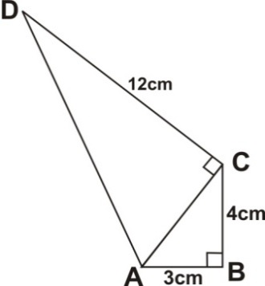

**(i)** Side **AC** is the hypotenuse of triangle ABC.

From the Pythagorean theorem,



⇒ 

⇒ 

⇒ 

⇒ 

⇒ 

Now, side **AD** is the hypotenuse of triangle ACD

From the Pythagorean theorem,



⇒ 

⇒ 

⇒ 

Hence the perimeter of ABCD

= 

= 

= 

The perimeter of ABCD is 32 cm

**2 (b) (ii)** Area of (ABCD = ∆ABC + ∆ACD)

= ½ (b1h1) + ½ (b2h2)

= 

= 

= 

The area of ABCD is 36 cm2

1. **(a)** 

= 

= 

= 

= 

= 

**3 (b)**  Distance ridden = *x* km

Distance walked = h × 6km/h = 3km

Total distance = 10 km

Dist. ridden + dist. walked = total dist.

⇒ *x* km + 3 km = 10 km

⇒ *x* km = 10 km – 3km

⇒ *x* km = 7 km

The distance Kwame covered by bicycle is 7 km

22cm

9cm

16cm

**3 (c) (i)**

**Volume** = length × width × height

= $22cm×9cm×16cm$

= 3168cm3

**Not drawn to scale**

22cm

9cm

16cm

6cm

d

Let *d* = the depth of water in the cylinder

**3 (c) (ii) Method 1** (Using calculated volume of rectangular tank)

Vol. of water in rectangular tank = Vol. of water in cylinder

⇒ 3168cm3  = *π r 2× d*

Simplifying

Substituting

⇒ 3168cm3  = 22/7 × (6cm)2  × d

⇒ 3168cm3  = 22/7 × 36cm2  × d

Dividing both sides by

22/7 × 36cm2

⇒ = d

⇒ = d

⇒ cm = d

You may avoid the tedious simplification here by using Method 2 below

⇒ $3168×\frac{7}{792}$ cm = d

⇒ 28 cm = d

Hence the depth of water in the cylindrical container = 28cm

**3(c)(ii)**  **Method 2** (Using the given dimensions of rectangular tank)

Vol. of water in cuboid = Vol. of water in cylinder

⇒ *l × w×h* cuboid *= π r 2× d* cylinder

[22cm × 9cm] × 16cm = [22/7 × (6cm)2] × d *Substituting and solving for d*

⇒ [22cm × 9cm] ×16cm = 

⇒  = d Simplifying

⇒  Simplifying (by ‘cancellation’)

⇒  = d

**∴** The depth (d) of water in the cylindrical container = 28cm.

1. **(a)**

**Method 1** (Evaluating whole number and fractions separately)



⇒ 

⇒ 

⇒ 

= 

**4 (a) Method 2** (Changing mixed fractions to improper fractions)



⇒ 

⇒ 

⇒ 

= 

**4 (b)**

31.5cm2

5.3cm

*h*

7.3cm

Let *h*  = perpendicular dist. between parallel sides

**Method 1** (Substituting first)

Area = ½ (sum of parallel sides) × *h*

⇒ 

Mulitiplying both sides by 2 to remove fraction

⇒ 

⇒ 

Dividing both sides by 12.6 cm to find ‘h’

⇒ 

Multiplying both numerator and denominator by 10 and breaking down by cancellation



⇒ 

**4 (b) Method 2** (Making *h* the subject first)

Let A = Area of trapezium

*c* + d = sum of parallel sides

*h* = perpendicular dist. between parallel sides

⇒ 

Mulitiplying both sides by 2 to remove fraction

⇒ 

⇒ 

⇒ 

Dividing both sides by ‘c+d’ to make ‘h’ the subject

⇒ 

Switching positions

⇒ 

Substituting values to find ‘h’

 = 

The perpendicular distance between the parallel sides is 5 cm.

**4 (c)**

**(i**) The mean mark = 

**(ii)** If the mean is less than 80 then , {*x: x* ≥ 0}

**(iii)**  

⇒ 

⇒ 

⇒ 

⇒ 

⇒  {*x: x* < 78*, x* ≥ 0}

The possible marks (*x*) that Efe scored in the test

= **0 ≤ *x* < 78**

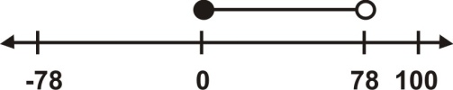

1. **(a)**

**Method 1** (Clearing fractions first)



⇒ 



Changing mixed fraction $2\frac{3}{4}$ to improper fraction

Multiplying through by 8 (to clear fractions):

⇒ 

Expanding and Simplifying

⇒ 

Grouping like terms on one side

⇒ 

⇒ 

Dividing both sides by 8 to find *x*

⇒  = 3

**5 (a)**

**Method 2**  (Grouping and simplifying terms containing the variable first)



⇒ 

Grouping the terms containing the variable

⇒ 

Simplifying

⇒ 

⇒ 

⇒ 

Cross multiplying

⇒ 

⇒ 

Simplifying and finding *x*

⇒ 32*x* = 88 + 8

⇒  =

⇒ 

**5 (b)**

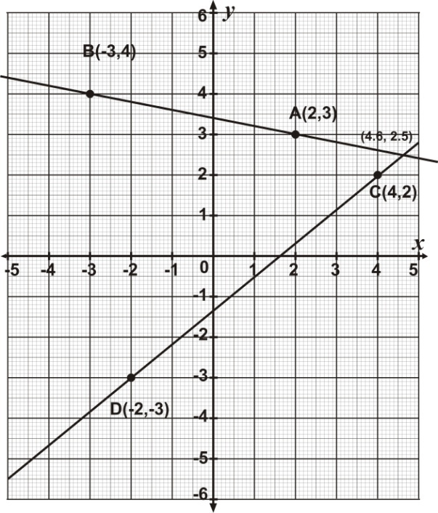

**5 (b) (iii)** The acute angle between lines AB and CD ≈ 50°

**5(b) (iv)** The coordinates of the point at which the lines through AB and CD meet

≈ (4**.**6, 2**.**5)

**(a) (i)** The Mode = The most-occurring number of letters

(the number of letters with the highest frequency)

⇒ The mode = 7 letters

**(ii)**

|  |  |  |
| --- | --- | --- |
| **No. of letters *(x)*** | **No. of students (*f)*** | ***f x*** |
| 4 | 7 | 28 |
| 5 | 3 | 15 |
| 6 | 2 | 12 |
| 7 | 8 | 56 |
| 8 | 5 | 40 |
| 9 | 3 | 27 |
| 10 | 1 | 10 |
|  | *Σf*= 29 | *Σfx*=188 |

The mean =  = 

=  ≈ 6.483

**6 (b)** P(surname has more than 7 letters)

= 

= 

= 

The probability that a student selected at random has a surname with more than 7 letters = 

**6 (c)**

**Vertical AxisScale: 2cm to 1 student**

