BECE Past Questions & Answers – 2012 (Science)

OBJECTIVE TEST
1 hour
1. The S.I. unit for measuring the work done by a force is
A. J. B. K. C. N. D. W.
2. The chemical formula of a compound describes the
A. number of molecules in the compound
B. type of bonding in the compound
C. ratio in which the elements are combined
D. state of the compound
3. Which of the following life processes is represented by the equation
Glucose +oxygen→carbon dioxide +water+ energy
A. Digestion
B. Excretion
C. Photosynthesis
D. Respiration
4. Each layer of soil profile is known as
A. horizon
B. litter
C. regolith
D. solum
5. When the p-n junction of a transistor is reverse biased
A. current flows from the p-type to the n-type
B. no current flows from the p-type to the n-type
C. conduction of current occurs
D. current flows from the n-type to the p-type
6. When a solid-liquid mixture is filtered, the liquid that separates out into the container is called
A. filtrate
B. residue
C. sediment
D. solution
7. Which of the following processes involves the solid state of matter?
A. Boiling
B. Condensation
C. Evaporation
D. Melting
8. Which of the following farming systems is most effective in maintaining soil fertility?
A. Crop rotation
B. Land rotation
C. Mixed cropping
D. Mono culture
9. The disease in humans which is associated within sufficient intake of calcium is
A. goiter
B. kwashiorkor
C. rickets
D. scurvy
10. The arrow in the circuit symbol of either n-p-n or p-n-p transistor is always on the
A. base lead
B. collector lead C. emitter lead D. receiver lead
11. Which of the following insect pests of crops has piercing and sucking mouthparts?
A. Aphids
B. Grasshoppers
C. Stem borers
D. Termites
12. A reflex action involves the
A. brain and muscles
B. brain and nerves
C. spinal cord and muscles
D. spinal cord and nerves
13. The type of image formed in a plane mirror is always
A. diminished
B. enlarged
C. real
D. virtual
14. Which of the following statements about acids are correct?
I. They turn red litmus paper blue
II. They can be classified as either organic or mineral acids
III. They can be neutralized by bases
A. I and II only B. I and III only C. II and III only D. I,II and III
15. A transistor is said to operate in an active region when
A. one p-n junction is forward biased and the other is reversed biased
B. base-emitter junctions are reversed biased
C. both p-n junctions are reversed biased
D. base-collector junction is forward biased
16. Tuberculosis is spread
A. through eating of contaminated food
B. when an infected person coughs openly into the air
C. through shaking of hands of infected persons
D. through sharing of contaminated syringes
17. One function of engine oil in the engine of a tractor is to
A. warm the engine
B. enhance air intake
C. ensure proper mixing of fuel
D. lubricate the engine parts
18. Blackpod is a disease of
A. cocoa
B. coffee
C. guava
D. mango
19. The efficiency of a machine is always less than 100% because part of the energy input is used to
A. stop the machine after working B. perform useful work on the load C. overcome friction
D. lift the machine up
20. Which of the following electronic components are used to produce oscillator circuits?
I. Transistor II. Inductor III. Capacitor
A. I and II only B. I and III only C. II and III only D. I,II andIII
21. Which of the following sources of light is natural?
A. Filament bulb
B. Fluorescent tube
C. Glow worm
D. Firecracker
22. Which of the following substances are carried by the blood?
I. Hormones
II. Urine
III. Oxygen
IV. Carbon dioxide
23. The practice of starting new organization in response to identified opportunities is termed
A. agribusiness
B. business enterprise
C. entrepreneurship
D. management
24. The sub-atomic particle with zero charge in the nucleus of an atom is called
A. electron
B. ion
C. neutron
D. proton
25. Which of the following management practices greatly helps in record keeping?
A. Culling
B. Debeaking
C. Dehorning
D. Identification
26. In the pin-hole camera,when the size of the pin-hole is increased, the image formed is
A. blurred
B. erect
C. magnified
D. virtual
27. Non-reactive metals are preferred in making ornaments and jewellery because they
A. are attractive
B. do not react with atmospheric oxygen
C. do not retain their lustre
D. are corrosive
28. Producers in an ecosystem are plants that
A. attract insects
B. feed on other plants
C. manufacture their own food
D. trap insects
29. The use of resistant varieties of crop in controlling diseases is described as
A. biological control method B. chemical control method C. cultural control method
D. physical control method
30. The chemical formula for aluminium oxide is represented as Al_{x}O_{y}. The values of x and y are respectively
A. 3 and 2
B. 3 and 1
C. 1 and 3
D. 2 and 3
31. In electrical circuits, the component that protects appliances against very high currents is the
A. capacitor
B. fuse
C. resistor
D. switch
32. One benefit of technology to industrialization is
A. environmental pollution
B. reduction in skillful labour
C. provision of machinery
D. increase in cost of production of goods
33. Which of the following factors contribute to early parenthood?
I. Poverty
II. Illiteracy
III. Lack of parental care
IV. Peer pressure
A. I and II only B. II and III only C. III and IV only D. I,II,III and IV
34. Which of the following examples of fertilizers improves soil texture?
A. Compost
B. NPK
C. Sulphate of ammonia
D. Urea
35. The reaction between hydrochloric acid and sodium hydroxide produces
A. sodium oxide only
B. sodium chloride only
C. sodium oxide and water
D. sodium chloride and water
36. In modern electrical wirings the colour code for the live wireis
A. blue
B. brown
C. green
D. green and yellow
37. An example of soil minor nutrient is
A. calcium
B. iron
C. nitrogen
D. phosphorus
38. The complete development of a human foetus in the womb normally takes
A.7 months B. 8 months C. 9 months D. 10 months
39. A material that allows a small amount of light energy to pass through it but cannot be seen through is referred to as
A. opaque
B. reflective C. translucent D. transparent
40. The leads of the transistor responsible for activation is the
A. amplifier
B. base
C. collector
D. emitter

OBJECTIVE TEST ANSWERS
1. C. N.
2. C.ratio in which the elements are combined
3. D.Respiration
4. A.horizon
5. B.no current flows from the p-type to the n-type
6. A.filtrate
7. D.Melting
8. A.Crop rotation
9. C. rickets
10. D.receiver lead
11. A.Aphids
12. D.spinal cord and nerves
13. D.virtual
14. C.II and III only
15. A. one p-n junction is forward biased and the other is reversed biased
16. B.when an infected person coughs openly into the air
17. D. lubricate the engine parts
18. A. cocoa
19. C.overcome friction
20. D. I,II and III
21. C. Glow worm
22. D. I,III and IV only
23. C.entrepreneurship
24. C.neutron
25. D. Identification
26. A. blurred
27. B.do not react with atmospheric oxygen
28. C.manufacture their own food
29. A.biological control method
30. D.2 and 3
31. B.fuse
32. C.provision of machinery
33. D.I,II,III and IV
34. A.Compost
35. D.sodium chloride and water
36. B.brown
37. B.iron
38. C.9 months
39. C.translucent
40. B.base

BECE Past Questions & Answers – 2012 (Science)
April2012
INTEGRATED SCIENCE 2
Essay
1 ¼ hours
PART I
[40marks]
Answer Question1
1. (a) The diagrams below are illustrations of an experiment in the laboratory using a piece of stone, a cork of mass 4.0g and other necessary materials.
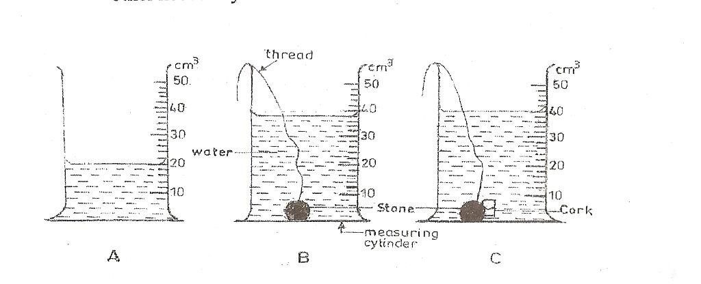
The initial volume of water in A was read and noted. A string was attached to a piece of stone
and the stone lowered gently into the water as shown in B. The volume was again read and noted. Finally, the cork of mass 4.0g was attached to the stone and both materials lowered gently into the water as shown in C. The volume was read and noted.
(i) Why did the level of the water rise when the stone was lowered gently into it as shown in diagram B?
(ii) Why was it necessary to attach the stone to the cork before lowering it gently into the water as shown in diagram C?
(iii) What would have happened if the cork alone were lowered gently into the water? (iv) What is the volume of the
(α) stone?
(β) cork?
(v) Calculate the density of the cork.
(vi) Why were the materials lowered gently into the water?
(b) A salt solution was prepared in the laboratory using the set of apparatus illustrated below.
Study the illustrations carefully and use them to answer the questions that follow.
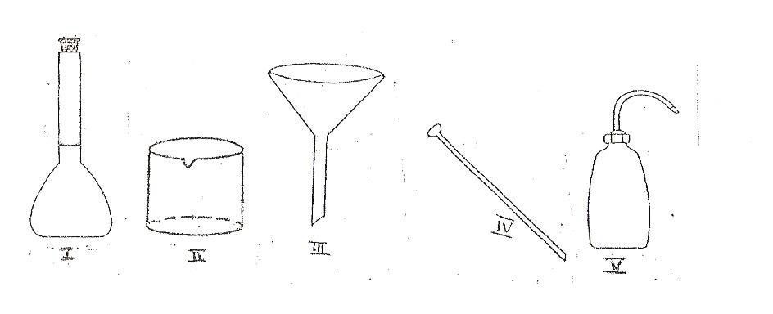
(i) Name each of the apparatus labeled I,II,III, IV and V.
(ii) State one function of each of the apparatus labeled I, II, III, IV and V. (c) The diagram below is an illustration of the external features of a flowering plant.
Study it carefully and use it to answer the questions that follow
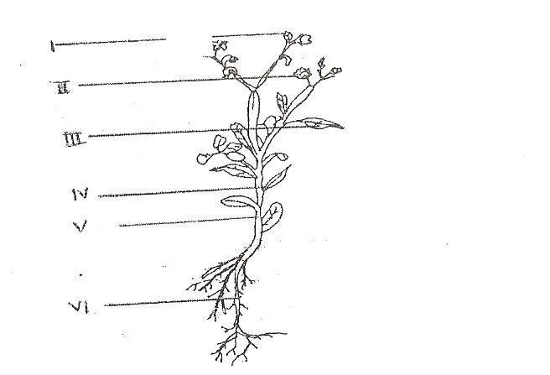
(i) Name the parts labeled I,II, III, IV, V and VI
(ii) State one function of each of the parts labeled I, II, III, V and VI
(iii) State the two main parts of a flowering plant
(d) The diagram below is an illustration of a small farm animal.
Study it carefully and use it to answer the questions that follow
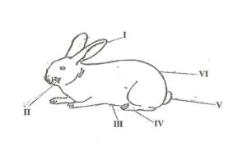
(i) Identify the animal
(ii) Name each of the parts of the animal labeled I, II,III, IV, V and VI
(iii) Name the structure in which the animal is kept
(iv) Mention three breeds of the animal.
(v) State two management practices to be adopted in order to control diseases and pests in the rearing of the animal.
PART II [60 marks]
Answer four questions only from this part
2.(a)(i)What is technology?
(ii) State one use of technology in communication
(b) Write and balance each of the following chemical equations:
(i) Fe+O₂→Fe2O₃;
(ii) Na+Cl₂→NaCl;
(iii) H₂+O₂→H₂O
(c) State one function of each of the following components of atypical cell:
(i) nucleus; (ii) chloroplast; (iii) mitochondrion
(d) Mention four cultural practices in vegetable crop production
(e) Name two agencies in food safety and quality assurance in Ghana.
3. (a) Explain why a tomato plant is likely to wilt if too much fertilizer is applied to it.
(b) (i) Give two differences between electrical insulators and electrical conductors.
(ii) State two effects of illegal electrical connections in the home.
(c) Explain each of the following terms as used to describe change of state of matter:
(i) condensation;
(ii) freezing
(d) (i) State two diseases of the circulatory system in humans
(ii) Mention two ways in which each of the diseases you have stated in (d)(i)can be prevented.
4. (a) (i) What is a transistor?
(ii) Give two uses of a transistor
(b) Mention the suitable solvent for each of the following solutes:
(i) grease;
(ii) ink stain
(iii) starch
(iv)cube sugar
(v)oil paint
(vi) iodine
(c)(i)What is a respiratory organ?
(ii)Name two structures of the respiratory system of humans.
(d)(i)What is agricultural chain?
(ii)Name two types of agricultural chain
5. (a) (i)What are stars?
(ii) Arrange in order, starting from the sun, the first four planets in the solar system.
(b)State
(i)two differences between plants and animals;
(ii) two similarities between plants and animals
(c) Explain each of the following farming systems:
(i) pastoral farming
(ii) ecological farming
(d) State the properties of water in terms of
(i) odour, (ii) taste, (iii) effect on litmus
6. (a) What are
(i) annual plants?
(ii) perennial plants?
(b) Mention one danger involved in each of the following activities in the laboratory:
(i) eating or drinking water in the laboratory;
(ii)washing hands with unknown liquid in a beaker;
(iii)walking bare footed.
(c)(i) What is a digestive enzyme?
(ii)Give two examples of digestive enzymes in humans.
(d) Give two differences between conduction and radiation of heat

April2012

INTEGRATEDSCIENCE2

SOLUTIONS

1. (a) (i) Why thelevel of water rose
The additional volumeofthe stone causedthewater to bedisplaced upwards
Or: dueto thespaceoccupied bythe stone

(ii) Why it wasnecessary toattachthestone tothecork
In orderforthe cork to betotallysubmerged in thewater
Or: in order forthe cork to stayunder thewater.

(iii) Whatwould havehappenedifthe corkalonewas lowered
It would have risen backup and floated on thewater
Or: itwould not havebeen able to stayunder thewater.

(iv) (α) Volume ofthe stone = 2nd reading– 1st reading

= 38 cm3– 20 cm3

= 18 cm3

(β) Volume ofthe cork = 3rd reading– 2ndreading

= 40cm3– 38cm3

= 2cm3

(v) Densityof the cork =

=

= 2g/cm3 or2gcm-3

(vi) Why thematerials wereloweredgently

To prevent thewaterfrom splashingwhich couldchangethe volume of thewater

Or: In order not to changethe first reading (ofthe initial volumeofwater)

(b) | (i) | I | - Measuringflask / volumetric flask /graduated flask
 |  | II | - Beaker
 |  | III | - funnel
 |  | IV | - Stirrer
 |  | V | - wash bottle

(ii) Functions

Apparatus | Functions
I | ✓Holdingaspecific volumeof liquid  ✓Preparation ofstandard solutions
II | ✓Measuringvolumes of liquids  ✓Holdingaliquid substance
III | ✓Transferringliquids from one container into another container (with  asmall neck or opening)  ✓Pouringliquids withoutspilling
IV | ✓Forstirringamixtureto makeituniform /homogeneous  ✓Forstirringto dissolveasolutein a solvent
V | ✓Addingwater (or other liquid) to mixtures /solutions / substances  ✓Rinsinglaboratoryequipment /apparatus
[any onefor each]

(c) | (i) | I | - bud
 |  | II | - flower
 |  | III | - leaf
 |  | IV | - leafstalk / petiole
 |  | V | - stem /internode

VI - roots

(ii)

Part | Function(s)
I | ✓Gives riseto a new flower orleaf or shoot
II | ✓Pollination (transfer ofpollen grains from anantherto thestigma of  the flower)  ✓Sexual reproduction (fusion of themale andfemalesexcells)  ✓Fruit and seed(s) production afterfertilization has occurred
III | ✓Photosynthesis(manufacturingfood usingwater,carbon,sunlight  and chlorophyll)  ✓Transpiration (loss of watervapourthrough stomata)  ✓Gaseous Exchange  ✓Food storagein some plants
V | ✓Supports /holdsthe branches andleaves of theplant  ✓Transports food from theleaves to otherparts  ✓Transports water and mineral saltsfrom the soil to otherparts  ✓Stores extra food
VI | ✓Holds theplant firmlyinthe ground  ✓Absorbs waterand mineral salt from thesoil fortheplant’s use.  ✓Stores extra food
[any onefor each]

(iii) Sexual Reproductivepart and vegetative part

(d) | (i)  (ii) | rabbit  I | - ear
 |  | II | - whiskers
 |  | III | - belly
 |  | IV | - hind limb / leg
 |  | V | - tail
 |  | VI | - rump

(iii) hutch
(iv) Alaska, American White, Chinchilla, Polish,Rose, English, Flemishgiant,Dutch, Beveren,etc,

[anythree]

(v) Practices to control diseases and pests
▪ Provision of clean drinkingwater andhealthyfeed
▪ Keepingthe hutchclean,wellventilated and at a suitable temperature at alltimes
▪ Regular veterinaryexamination / services of therabbits
▪ Separatingunhealthyor infectedanimals from thehealthyones
▪ Vaccination againstinfections / diseases
[anytwo]

2. | (a) | (i) | Technology  Theuse of scientificknowledgeto solve problems in everydaylife
 |  |  | Or
 |  |  | The application ofscientificknowledgeand methods to makelife/ work easier, fasterand
 |  |  | more comfortable
 |  |  | Or
 |  |  | Thestudy, development,and application ofdevices, machines, and techniques for
 |  |  | manufacturing and productiveprocesses

(ii) | Us  ▪ | es oftechnology incommunication  Makingtelephonecalls
 | ▪ | Sendingatext messages
 | ▪ | Sendingafax
 | ▪ | Sendingane-mail
 | ▪ | Online chatting (on social networks)
 | ▪ | Searchingforinformationon the internet
 | ▪ | Typingand printingdocuments
 | ▪ | Photocopyingdocuments
 | ▪ | Scanningdocuments
[any one]

(b) | (i) | 4Fe | + | 3O2 | → | 2Fe2O3
 | (ii) | 2Na | + | Cl2 | → | 2NaCl
(c) | (iii) | 2H2 | + | O2 | → | 2H2O

(i)
Component | Function
Nucleus | ▪ Controls the lifeactivities ofthe cell  ▪ Contains thegenes (forhereditarytraits)  ▪ Controls cellreproduction

(ii)
Chloroplast | ▪ Contains chlorophyll, which absorbs energy  from sunlight /light
Mitochondrion | ▪ Generate chemical energyfor cellfunctions  ▪ Control cell cycle / cellgrowth and death

(iii)

(d) Cultural practices invegetable crop production
▪Weeding
▪Stirring(the soil)
▪Watering/ irrigation
▪Earthingup
▪Mulching
▪Thinningout
▪Pruning
▪Staking
▪Supplying-in
▪Application of fertilizer
[any four]

(e) Agencies in foodsafety andquality assurance
▪ Food and Drugs Board
▪ GhanaStandards Board
▪ Ministryof Foodand Agriculture
▪ Ministryof Health
▪ Plant Protection and RegulatoryServices Department
[any two]

3. | (a) | Why a tomato plant is likely to wiltiftoo much fertilizeris appliedto it.
 |  | Nitrogen-richfertilizers encouragetopgrowth oftomato plants at the expense of root formation. Oncehot weatherbegins, the root system is insufficient to transport the water needed to keep the top greengrowthalive, and the plant wilts.

(b) (i) Differences

Electrical Insulators | Electrical Conductors.
Does not allow electricityto flow through | Allows electricityto flow through
Has no free electrons | Has free electrons
Has a wideforbiddenenergygap | Has no forbiddenenergygap
Electrons are firmlybound to thenucleus | Electrons arelooselybound to thenucleus

(ii) Effects ofillegal electrical connectionsinthehome.
▪ Improper workingof electrical appliances
▪ Fireoutbreaks
▪ Destruction of electrical appliances
▪ Power cuts
▪ Financial waste

(c) Explanationas usedtodescribe changeofstateofmatter: (i) Condensation;
The changeof thephysical state ofmatterfromgaseousstateinto liquidstate
Or
Theprocess bywhich avapour loses heat and changes into aliquid
This happens because thevapourmolecules slow down dueto theheat lossand the distances between molecules reduce.

(ii) Freezing
The changeof thephysical state ofmatterfrom the liquid state to the solidstate
Or:
Theprocessbywhich aliquid loses heat and changes into asolid
This happens because theliquidmolecules slow down and stop movingabout randomly dueto theheat loss and thedistances between molecules reduce.

(d) | (i) | State two diseases ofthe circulatory system inhumans  Haemorrhoid
 |  | High blood pressure
 |  | Low blood pressure
 |  | Leukemia
 |  | Arteriosclerosis
[anytwo]

(ii) Ways inwhichthediseases statedin(d) (i)can beprevented.

DISEASES | PREVENTION
Haemorrhoid | ▪ Drinkinglots of water  ▪ Eatingalotoffruits andvegetables  ▪ Freeingthebowels asfrequentlyas possible  ▪ Exercisingthe bodyregularly  ▪ Usinghygienicand soft toilet paper
High blood pressure | ▪ Reducingsaltintake  ▪ Avoidingdrinkingalcoholicbeverages  ▪ Avoidingsmoking  ▪ Exercisingregularly  ▪ Having enoughsleep

▪ Reducing emotional stress
▪ Reducing fat intake
▪ Increasing fruits andvegetableintake
Leukemia | ▪ Avoidingexposureto certain radiations  ▪ Avoidingexposureto certain chemicals  ▪ Avoidingsmoking
Arteriosclerosis | ▪ Exercisingthe bodyregularly  ▪ Reducingthe intakeof animal fat  ▪ Takingmore fruits and vegetables  ▪ Avoidingsmoking

4. | (a) | (i) | A transistor
 |  |  | A smalllow-powered solid-state electronicdeviceconsistingof asemiconductor and at least threeelectrodes, theemitter, thebaseand thecollector
 |  | (ii) | Uses ofa transistor
- As current amplifiers
- As current rectifier
- As an electronicswitch in integrated circuits
- As a regulator– to regulate current, voltageor power.
- Used in oscillator circuits

(b) | (i) | SOLUTE  Grease; | SOLVENT  Petrol/ kerosene
 | (ii) | Ink stain | Isopropyl /rubbing alcohol
 | (iii) | Starch | Cold water
 | (iv) | Cubesugar | Warm water
 | (v) | Oil paint | Turpentine
 | (vi) | Iodine | ethanol / diethyl ether / aceticacid /benzene

(c) | (i) | A respiratory organ  Anyorgan ofalivingorganismthatis involved inthe process ofrespiration
 | (ii) | Structures ofthe respiratory systemof humans.  Nostrils, pharynx, larynx, trachea, bronchi, bronchioles, alveoli, ribs, diaphragm,
intercostal muscle, ribs, (lungs)
[anytwo]
(d) | (i) | Agriculturalchain  Thelinkageof stages that areinterconnected in theproduction and supplyofagricultural
 |  | goods and services

(ii) Types ofagricultural chain
▪ Production chain
▪ Processing chain
▪ Value chain
▪ Supplychain

5. | (a) | (i) | Stars
 |  |  | Stars areheavenlybodiesthat aremadeup mostlyofburning gases
 |  | (ii) | Thefirstfour planets in order  Mercury,Venus, Earth, Mars

(b) State
(i) Differences

PLANTS | ANIMALS
Manufacturetheirownfood  (photosynthesis) | Do not manufacturetheirown food
Cannot move freelyfromplaceto place | Ableto move freelyfromplaceto place
Mostplants do not respond quicklyto  stimuli | Respond quicklyto stimuli
Haveacellwall | Do not haveacellwall
Have chloroplasts, whichcontain  chlorophyll | Do not have chloroplast
Excess carbohydrates arestored as starch | Excess carbohydrates arestored as  glycogen
Absorb carbondioxide for  photosynthesis and releaseoxygen as waste product | Inhale oxygenforrespiration and release carbondioxide as wasteproduct
Cells havelargeand permanent vacuoles | Cells havesmall temporaryvacuoles
Growth takes place at specific parts | Growth takes place atallparts

[any two] (ii) Similarities between plants and animals
Both plants and animalsarelivingthings /organisms
▪ Both plants and animals respire
▪ Both plants and animalsgrow
▪ Both plants and animals reproduce
▪ Both plants and animals feed
▪ Both plants and animalsexcrete
[any two]

(c) Explanation
(i) Pastoral farming
A farmingsystem in which farmanimalssuch ascattle and sheep aremoved from place to placein search offoodand water.The animals feed on natural vegetationand drink waterfrom water bodiessuch as streams, rivers, ponds, etc

(ii) Ecological farming
A method of farminginwhich the natural vegetationand animalsand theirenvironment arepreserved
Chemicals andheavymachineryarenot used. Thesoil is fertilized usingorganicmanure, such as animal droppings. Pestsand diseases arecontrolled biologically, ie,using
resistant crops andanimals

(d) Properties of water
 |  | (i) | Odour- Wateris odourless (it has no odour/ smell)
 |  | (ii) | Taste - Wateris tasteless (it has no taste)
 |  | (iii) | Effect on litmus-Waterturns red or blue litmus paper to purple.
6. | (a) | (i) | Annualplants  Plants that completetheirlifecycle in oneseasonoroneyear
 |  | (ii) | Perennial plants  Plants that continue to live forseveralyears (usuallythreeor more)

(b) Dangers involved in

(i) Eating ordrinkingwaterinthelaboratory;
▪ The food ordrinkcangetcontaminated bytoxic substances, whichcould lead to poisoning
▪ The food ordrinkcan spillor drop into othersubstancesin thelaboratory,which could lead to accidents and injuries.

(ii) Washing handswithunknownliquidinabeaker;
▪ Theunknown liquid could be toxic, which will cause fatal injuries or even death.

- Theunknown liquid could be harmful or irritant, which could causesevere harm or injuries orirritation to thehands or body

(iii) Walkingbarefooted.
▪ One could step on aslipperysubstanceand slip orfall, causinginjuries to thebody
▪ One could step on atoxic orirritant substance, which could causesevereharm or injuries orirritation to the feet or body

(c) (i) Digestive enzyme
A biologicalcatalyst which speeds up thedigestion of food substances in thebodyof an animal
Or
A complexchemical, produced in thebodyof ananimal, which speeds up theprocess of digestion

(ii) Examples of digestive enzymes in humans.
Ptyalin, pancreaticamylase, trypsin, pepsin, rennin,lipase, maltase
[anytwo]

(d) Differences

Conduction | Radiation
Requires a material medium | Does not requireamaterial medium
Process is relativelyslow | Process is relativelyveryfast
Heat is transferred bycontact of  molecules or atoms. | Heat is transferred bywaves or rays

