EaD Comprehensive Lesson Plans
or 0248043888

NAME OF TEACHER: ………………………………………………… WEEK ENDING…13-01-2023………………
NUMBER ON ROLL: ………………………………………………… SUBJECT… ENGLISH LANGUAGE
DURATION: ………………………………………………………….... REFERENCE…SYLLABUS(CRDD,2007), ENG. FOR JHS
FORM……………..BASIC 9…………… WEEK……………1……..

DAY/DURATION | TOPIC/SUB-TOPIC/ASPECT | OBJECTIVES/R.P. K | TEACHER-LEARNER ACTIVITIES | T/L MATERIALS | CORE POINTS | EVALUATION AND REMARKS
WEDNESDAY  11:00 AM-12:10PM  70mins | Topic:  Revision – Discussion of Last Term Examination Questions.  Paper II | Objectives  By the end of the lesson, pupils will be able to;  - Remember previous lesson taught.  - Answer all questions in the examination.  R.P.K  Pupils have been answering examination questions. | Introduction.  Select a model reader to read Paper II (writing Part) questions to the class.  - Learners to raise hands up to answers questions.  - Call Learners at random to answer questions.  - Discuss with Learners challenging questions.  - Learners brainstorm to answer practical questions  Conclusion  Through questions and answers, conclude the lesson. | 1. Examination Questions.  2. Note books  3. Textbook. | Sample of Questions;  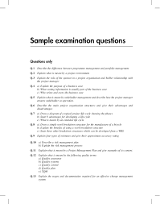
THURSDAY  9:15AM – 10:25AM  70mins | Topic:  Revision – Discussion of Last Term Examination Questions.  Multiple Choice questions. | Objectives  By the end of the lesson, pupils will be able to;  - Remember previous lesson taught.  - Answer all questions in the examination.  R.P.K  Pupils have been answering examination questions. | Introduction.  A model reader to read multiple choice questions to the class is to be selected by the Facilitator.  - Call individual Learners by names to answer multiple choice questions.  - Discuss challenging topics with the Learners  Conclusion  Through questions and answers, conclude the lesson. |  | Sample of Questions  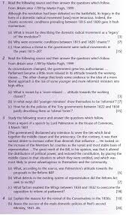 | Remarks

