EaD Comprehensive Lesson Plans
or 0248043888

NAME OF TEACHER: ………………………………………………… WEEK ENDING…20-01-2023………………
NUMBER ON ROLL: ………………………………………………… SUBJECT… ENGLISH LANGUAGE
DURATION: ………………………………………………………….... REFERENCE…SYLLABUS(CRDD,2007), ENG. FOR JHS ……
FORM……………..BASIC 9…………… WEEK………2…………..
DAY/DURATION | TOPIC/SUB-TOPIC/ASPECT | OBJECTIVES/R.P. K | TEACHER-LEARNER ACTIVITIES | T/L MATERIALS | CORE POINTS | SKILLS ACQUISITION
MONDAY  9:15AM - 10:25AM  70min | Aspect;  Listening and speaking  Topic;  Revision of Vowels and Consonants | Objectives  By the end of the lesson, pupils will be able to;  articulate difficult sounds  correctly  RPK  Pupils can already identify sounds of letters | Introduction;  Assist Pupils to differentiate between Consonants and Vowels.  Activities;  - Discuss with Pupils examples of vowels and consonants.  - Pupils brainstorm to form words with vowels and consonants.  - Assist Pupils to pronounce words formed with vowels and consonants.  Closure;  Through questions and answers, conclude the lesson. | - Sentence cards  - Wordcharts  - Letter cards | Consonants;  In English, these letters are B, C, D, F, G, J, K, L, M, N, P, Q, S, T, V, X, Z and often H, R, W, Y.  Vowels;  B, C, D, F, G, H, J, K, L, M, N, P, Q, R, S, T, V, X, and Z.  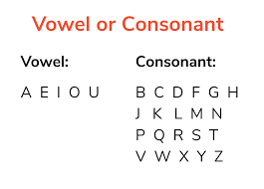 | - Listening skills  - Oral skills  - Communication skills.  - Identification of sounds.
TUESDAY  8:05AM – 9:15AM | Aspect;  Grammar  Topic;  Relative Clauses | Objectives  By the end of the lesson, pupils will be able to;  construct sentences containing relative clauses.  RPK  Pupils were taught lessons on Relative Clauses in basic 8. | Introduction;  Discuss the meaning of Relative Clauses with the Learners.  Activities;  - Pupils brainstorm to give examples of relative clauses and their functions.  - Assist Pupils to identify relative clauses in sentences.  Closure;  Pupils in small groups identify relative clauses in sentences. |  | 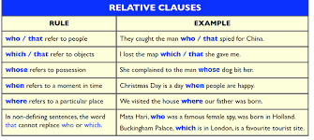  Relative Clauses usually begin with that, who, whom, which.  Relative clauses usually come immediately after the nouns they relate to.  They qualify or describe the nouns they relate to.  Examples are;  The girl who won the prize is my sister.  The dog which guards the house is very fearful | - Communication skills  - Reading skills  - Listening skills  - Speaking skills
THURSDAY  9:15AM – 10:25AM  70mins | Aspect;  Writing  Topic;  Consolidation | Objectives  By the end of the lesson, pupils will be able to;  write a composition using punctuation marks appropriately.  RPK  Pupils have been using punctuation marks in writing of letters. | Introduction;  Show Pupils a Poster bearing Punctuation marks and ask Pupils to identify them by their names.  Activities;  - Assist Pupils to write sentences using Punctuation marks.  - Discuss the functions of Punctuation marks with the Pupils.  - Individual Pupils are to be assisted to write full compositions with Punctuation marks.  Closure;  Discuss with Pupils the importance of using Punctuation marks in writing compositing. |  | Punctuation is the use of spacing, conventional signs, and certain typographical devices as aids to the understanding and correct reading of written text, whether read silently or aloud.  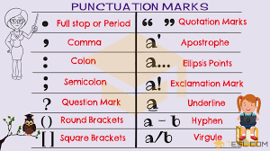 | - ability to generating ideas to topics  - knowledge of organizational patterns  - knowledge of syntactic competences  - Writing skills
FRIDAY  12:00PM – 1:10PM | Aspect;  Reading  Topic  Comprehension | Objectives  By the end of the lesson, pupils will be able to;  read silently with  understanding.  RPK  Pupils can read paragraph | Introduction;  - Discuss with Pupils the meanings of Keywords or vocabularies  - Pupils brainstorm to read comprehension passages.  - Assist Pupils to answer comprehension questions  Activities;  Through questions and answers, conclude the lesson.  Closure; |  | How to answer comprehension questions – Step-by-step  - Identify and restate the keywords in the question.  - Present your answer.  - Incorporate your evidence.  - Explain your example.  - Conclude your response.  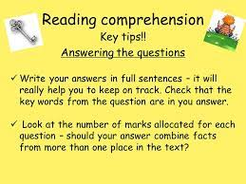 | 1.Reading skills  2. listening skills  3. oral skills  4. critical thinking

Name of Teacher: School: District:

