EaD Comprehensive Lesson Plans
or 0248043888
NAME OF TEACHER: ………………………………………………… WEEK ENDING…2O-01-2023………………
NUMBER ON ROLL: ………………………………………………… SUBJECT: PRE-TECHNICAL SKILLS
DURATION: ………………………………………………………….... REFERENCE…SYLLABUS(CRDD,2007), PRE-TECH FOR JHS ……
FORM……………..BASIC 9…………… WEEK………2…………..
DAY/DURATION | TOPIC/SUB-TOPIC/ASPECT | OBJECTIVES/R.P. K | TEACHER-LEARNER ACTIVITIES | T/L MATERIALS | CORE POINTS | EVALUATION AND REMARKS
TUESDAY  9:15AM - 10:25AM  70min | Topic;  Metals(cast iron)  Sub-Topic;  Examples of Cast Iron Products. | By the end of the lesson the Pupil will be able to;  i. identify cast iron  RPK  Pupils use cast iron products. | Introduction;  Discuss meanings of keywords and terminologies in the lesson with the Pupils.  Activities;  - Display cast iron products on a table in front of the class and ask Pupils to identify them.  - Assist Pupils to describe the uses of the various cast iron products.  - Demonstrate using a cast iron product for Pupils to observe.  Closure  Assist Individual Pupils to use cast iron products. | frying pans, griddles, waffle irons, flattop grills | Cast Iron;  cast iron is an alloy of iron that contains 2 to 4 percent carbon, along with varying amounts of silicon and manganese and traces of impurities such as sulphur and phosphorus.  Examples of Cast Iron Products;  - frying pans  - dutch ovens  - griddles  - waffle irons  - flattop grills  - panini presses  - crepe makers  - deep fryers  - Tetsubin  - Woks  - Potjies  - karahi.  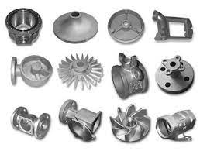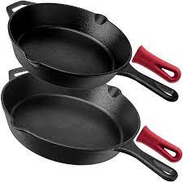 | Exercise;  - What is a Cast Iron?  - Write 5 examples of Cast Iron products.  - Explain the uses of cast iron products
THURSDAY  9:15AM – 10:25AM  70mins | Topic;  Metals(cast iron)  Sub-Topic;  Properties and uses of Cast Iron. | Objectives;  By the end of the lesson the Pupil will be able to;  state the properties and uses  of cast iron.  RPK  Pupils use cast iron products. | Introduction  Review Pupils knowledge on the previous lesson.  Activities;  - Show Learners video and pictures of Cast Iron products.  - Discuss the properties of Cast iron with the Pupils.  - Assist Pupils to explain the properties of Cast Iron.  Closure  Through questions and answers, conclude the lesson. |  | Properties of Cast Iron;  - relatively low melting point  - good fluidity  - castability  - excellent machinability  - resistance to deformation  - wear resistance  Uses of Cast Iron;  - electrical fittings and equipment  - hand tools  - pipe fittings  - Washers  - Brackets  - farm equipment  - mining hardware  - machine parts.  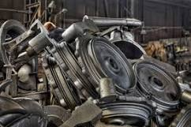 | Exercise;  - Explain 5 properties of Cast Iron.  - State 5 uses of Cast Iron.

Name of Teacher: School: District:

