EaD Comprehensive Lesson Plans
or 0248043888
NAME OF TEACHER: ………………………………………………… WEEK ENDING……20-01-2023……………
NUMBER ON ROLL: ………………………………………………… SUBJECT… SCIENCE
DURATION: ………………………………………………………….... REFERENCE…SYLLABUS(CRDD,2007), FOR JHS ……
FORM……………..BASIC 9…………… WEEK……………2……..
DAY/DATE | TOPIC/SUB-TOPIC/ASPECT | OBJECTIVES/R.P. K | TEACHER-LEARNER ACTIVITIES | T/L MATERIALS | CORE POINTS | EVALUATION AND REMARKS
TUESDAY  9:15AM - 10:25AM  70min | Topic:  Acids and Bases  Sub Topic:  Meaning of Acid and Base | Objectives  By the end of the lesson, pupils will be able to;  - Explain the term Acid and Base  - Properties of Acid and Base.  RPK  Pupils were taught lessons on Acid and Base in Basic 7. | Introduction.  Using a Power Point Presentation, explain the meaning of Acid and Base.  Activities  - Pupils brainstorm to identify the properties of Acid and Base.  - Assist Pupils to explain the meanings of the properties of Acid and Base.  - Discuss with Pupils examples of Food stuffs that contain Acid.  Conclusion  Reflect on the properties of Acid and Base. | Moistened litmus paper, unripe orange,  lemon, aspirin, vinegar, wood ash | Properties of Acids and Bases  1. Properties of Acids  - Acids are corrosive in nature.  - They are good conductors of electricity.  - Their pH values are always less than 7.  - When reacted with metals, these substances produce hydrogen gas.  - Acids are sour in taste.  - Examples: Sulfuric acid [H₂SO₄], Hydrochloric acid [HCl], Acetic acid [CH₃COOH].  2. Properties of Bases  Some properties, like a bitter taste, are owned by all bases. The bases feel slippery, too. Dream on what slippery soap looks like. And this is a foundation. Furthermore, when immersed in water, bases conduct electricity because they consist of charged particles in the solution.  - They are found to have a soapy texture when touched.  - These substances release hydroxide ions (OH– ions) when dissolved in water.  - In their aqueous solutions, bases act as good conductors of electricity.  - The pH values corresponding to bases are always greater than 7.  - Bases are bitter-tasting substances which have the ability to turn red litmus paper blue.  - Examples: Sodium hydroxide [NaOH], milk of magnesia [Mg(OH)₂], calcium hydroxide [Ca(OH)₂].  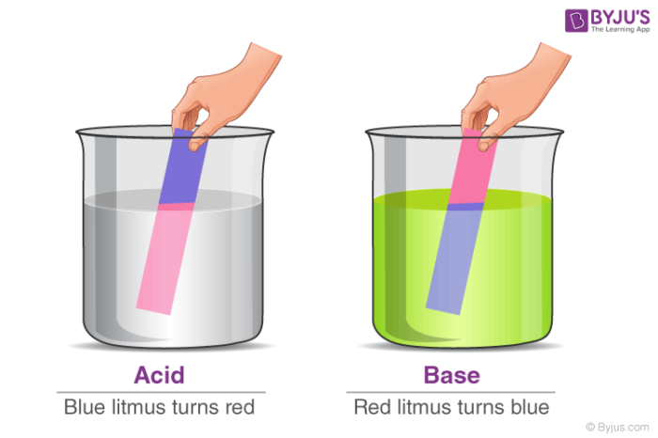 | Exercise  - What is Acid and Base?  - State 5 properties of Acid and Base.
WEDNESDAY  11:00 AM-12:10PM  70mins | Topic:  Acid and Base  Sub Topic:  Difference between Acid and Base. | Objectives  By the end of the lesson, pupils will be able to;  distinguish between  an acid and a base.  RPK  Pupils were taught lessons on Acid and Base in Basic 7 | Introduction.  Show Pupils a Poster displaying the differences between Acid and Base.  Activities  - Pupils brainstorm to distinguish between Acid and Base.  - Engage Pupils in practical works to prove the differences between Acid and Base.  Conclusion  Through questions and answers, conclude the lesson |  | 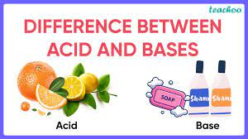  Difference between Acids and Bases  Acids Bases  Acid gives off hydrogen ions when dissolved in water. Bases give off hydroxyl ion when dissolved in water.  It turns blue colour litmus paper into red. It turns red colour litmus paper into blue.  It has a sour taste. It has bitter taste and soapy to touch.  Its pH value ranges from 1 to 7. Its pH value ranges from 7 to 14.  Example: HCl, H₂SO₄ etc. Example: NaOH, KOH etc. | Assignment  Tabulate 5 differences between Acid and Base.
THURSDAY  9:15AM – 10:25AM  70mins | Topic:  Acid and Base  Sub Topic:  Classifying Substances as Acid and Base | Objectives  By the end of the lesson, pupils will be able to;  classify substances  as acids or bases.  RPK  Pupils have been eating food that contains Acid . | Introduction.  Review Pupils knowledge on the previous lesson.  Activities  - Discuss the process of testing the acidity content of substances.  - Assist Pupils to classify substances as Acid or base.  - Pupils brainstorm to identify examples of Acidic and Basic substances.  Conclusion  Through questions and answers, conclude the lesson. |  | pH of Acids and Bases  In order to find the numeric value of the level of acidity or basicity of a substance, the pH scale (wherein pH stands for ‘potential of hydrogen’) can be used. The pH scale is the most common and trusted way to measure how acidic or basic a substance is. A pH scale measure can vary from 0 to 14, where 0 is the most acidic and 14 is the most basic a substance can be.  Another way to check if a substance is acidic or basic is to use litmus paper. There are two types of litmus paper available that can be used to identify acids and bases – red litmus paper and blue litmus paper. Blue litmus paper turns red under acidic conditions and red litmus paper turns blue under basic or alkaline conditions.  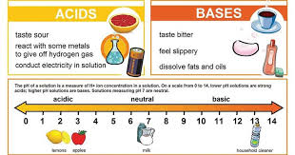 | Exercise;  Classify 5 substances as Acid or Base.  Remarks

Name of Teacher: School: District:

