EaD Comprehensive Lesson Plans
or 0248043888
NAME OF TEACHER: ………………………………………………… WEEK ENDING……03-02-2023……………
NUMBER ON ROLL: ………………………………………………… SUBJECT… MATHEMATICS
DURATION: ………………………………………………………….... REFERENCE…MATHS SYLLABUS(CRDD,2007), MATHS FOR JHS ……
FORM……………..BASIC 9…………… WEEK…………4………..
DAY/DATE | TOPIC/SUB-TOPIC/ASPECT | OBJECTIVES/R.P. K | TEACHER-LEARNER ACTIVITIES | T/L MATERIALS | CORE POINTS | EVALUATION AND REMARKS
MONDAY  9:15AM - 10:25AM  70min | Topic;  Application of Sets  Sub-Topic;  Word Problem using Venn Diagram | By the end of the lesson the Pupil will be able to;  Solve word problems using Venn Diagram.  RPK  Pupils have representing sets of numbers on a Venn Diagram. | Introduction  Discuss examples of word problems questions about sets of numbers.  Activities  - Show Pupils a video of how to solve word problems using Venn Diagram  - Assist Pupils to solve word problem using a Venn Diagram.  Closure  Through questions and answers, conclude the lesson. | Chart, Pictures Power point Presentation. | Represent the Universal Set (U) = {x : x is an outcome of a dice’s roll} and set A = {s : s ϵ Even numbers} through a Venn diagram.  Answer : Since, U = {1, 2, 3, 4, 5, 6} and A = {2, 4, 6}. Representing this with a Venn diagram we have:  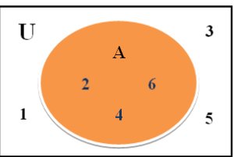  Here, A is a subset of U, represented as – A ⊂ U or  U is the superset of A, represented as – U⊃ A  If A = {1, 2, 3, 4, 5} and B = {4, 5, 6, 7, 8},  then represent A – B and B – A through Venn diagrams.  A – B = {1, 2, 3}  B – A = {6, 7, 8}  Representing them in Venn diagrams:  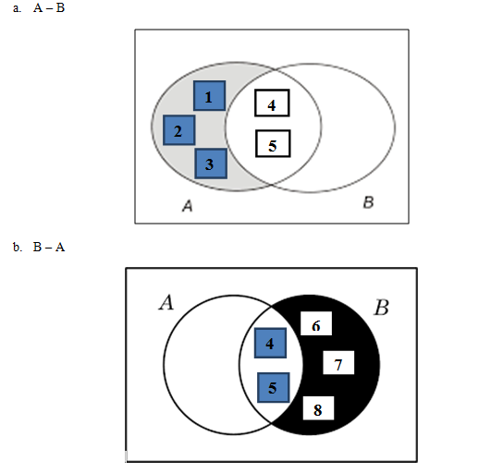  Use Venn diagrams in different situations to find the following sets.  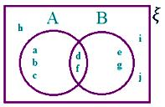  5Save  (a) A ∪ B  (b) A ∩ B  (c) A'  (d) B - A  (e) (A ∩ B)'  (f) (A ∪ B)'  Solution:  ξ = {a, b, c, d, e, f, g, h, i, j}  A = {a, b, c, d, f}  B = {d, f, e, g}  A ∪ B = {elements which are in A or in B or in both}  = {a, b, c, d, e, f, g}  A ∩ B = {elements which are common to both A and B}  = {d, f}  A' = {elements of ξ, which are not in A}  = {e, g, h, i, j}  B - A = {elements which are in B but not in A}  = {e, g}  (A ∩ B)' = {elements of ξ which are not in A ∩ B}  = {a, b, c, e, g, h, i, j}  (A ∪ B)' = {elements of ξ which are not in A ∪ B}  = {h, i, j} | Exercise;  - There are 35 students in art class and 57 students in dance class. Find the number of students who are either in art class or in dance class.  - In a group of 100 persons, 72 people can speak English and 43 can speak French. How many can speak English only? How many can speak French only and how many can speak both English and French?  - In a competition, a school awarded medals in different categories. 36 medals in dance, 12 medals in dramatics and 18 medals in music. If these medals went to a total of 45 persons and only 4 persons got medals in all the three categories, how many received medals in exactly two of these categories?
TUESDAY  10:50AM – 12:00PM  70min | Topic;  Application of Sets  Sub-Topic;  Relationship in set using Venn Diagram | By the end of the lesson the Pupil will be able to;  Find the relationship in sets using Venn Diagram.  RPK  Pupils have been solving Venn Diagram questions. | Introduction  Through questions and answers, review Pupils knowledge on the previous lesson.  Activities  - Demonstrate how to find the relationship in sets using Venn Diagram.  - Assist Pupils to find the relationship in sets of numbers using Venn Diagram.  Closure  Assign a group work to small groups of Pupils to find the relationship in sets of numbers using Venn Diagram. |  | • The union of two sets can be represented by Venn diagrams by the shaded region, representing A ∪ B.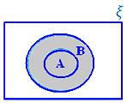  A ∪ B when A ⊂ B  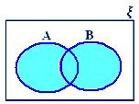  A ∪ B when neither A ⊂ B nor B ⊂ A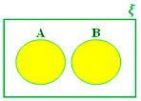  A ∪ B when A and B are disjoint sets  Relationship between the three Sets using Venn Diagram  • If ξ represents the universal set and A, B, C are the three subsets of the universal sets. Here, all the three sets are overlapping sets.  Let us learn to represent various operations on these sets.  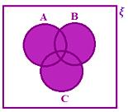  A ∪ B ∪ C  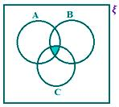  A ∩ B ∩ C  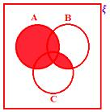  A ∪ (B ∩ C)  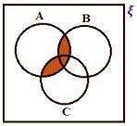  A ∩ (B ∪ C)  Some important results on number of elements in sets and their use in practical problems.  Now, we shall learn the utility of set theory in practical problems.  If A is a finite set, then the number of elements in A is denoted by n(A).  Relationship in Sets using Venn Diagram  Let A and B be two finite sets, then two cases arise:  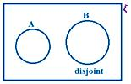 | Exercise  1. If A and B are two sets such that number of elements in A is 24, number of elements in B is 22 and number of elements in both A and B is 8, find:  (i) n(A ∪ B)  (ii) n(A – B)  (iii) n(B – A)  2.According to the survey made among 200 students, 140 students like cold drinks, 120 students like milkshakes and 80 like both. How many students like atleast one of the drinks?
FRIDAY  9:15AM – 10:25AM  70mins | Topic;  Application of Sets  Sub-Topic;  Venn Diagram 3 set Problem. | Objective  By the end of the lesson the Pupil will be able to;  Solve 3 set Venn Diagram problems.  RPK  Pupils have been solving Venn Diagram questions. | Introduction  Pupils brainstorm to compare 3 set problem of Venn diagram to 2 set problem.  Activities  - Demonstrate solving 3 set problem of Venn diagram.  - Pupils brainstorm to solve 3 set problem questions of Venn diagram.  Closure  Through questions and answers, conclude the lesson. |  | 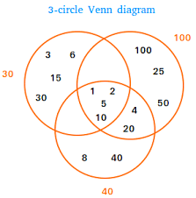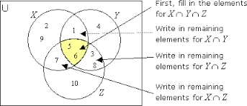  P, Q and R are subsets of a universal set U. If n(U) = 390, n(P) = 210, n(Q) = 165, n(R) = 120, n(P∩Q) = 60, n(Q∩R) = 45, n(A∩R) = 54 and n(P∩Q∩R) = 24, illustrate this information in a Venn-diagram and find the following:  a. n_{o}(P)  b. n_{o}(Q)  c. n_{o}(R)  d. n_{o}(P∩Q)  e. n_{o}(Q∩R)  f. n_{o}(P∩R)  g. n(P∪Q∪R)^{c}  Solution:  Here,  Venn-diagram,  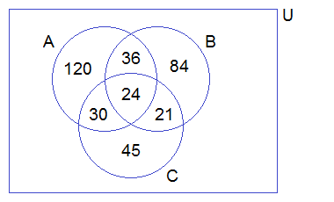  From the Venn-diagram above,  a. n_{o}(P) = 120  b. n_{o}(Q) = 84  c. n_{o}(R) = 45  d. n_{o}(P∩Q) = 36  e. n_{o}(Q∩R) = 21  f. n_{o}(P∩R) = 30  g. n(P∪Q∪R)^{c} = 30 | Exercise;  - In a survey of a group of people, 60 liked tea, 45 liked coffee, 30 liked milk, 25 liked coffee as well as tea, 20 liked tea as well as milk, 15 liked coffee as well as milk and 10 liked all three. How many people were asked this question? Solve by using Venn-diagram.  - In an examination, 40% of candidates passed in mathematics, 45% in Science, and 55% in Health. If 10% passed in Mathematics and Science, 20% in Science and Health and 15% in Health and Mathematics,  (i) Illustrate the above information by drawing a Venn diagram.  (ii) Find the pass percentage in all three subjects.  - Out of 1350 candidates, 600 passed in Science, 700 in Mathematics, 350 in English and 50 failed in all three subjects. If 200 passed in Science and Mathematics, 150 in Science and English, 100 in Mathematics and English,  (i) How many candidates passed in all three subjects?  (ii) Illustrate the above information in a Venn-diagram.

Name of Teacher: School: District:

