EaD Comprehensive Lesson Plans
or 0248043888
WEEKLY LESSON PLAN
NAME OF TEACHER: ………………………………………………… WEEK ENDING…10-02-2023………
NUMBER ON ROLL: ………………………………………………… SUBJECT… SOCIAL
DURATION: ………………………………………………………….... REFERENCE…SYLLABUS(CRDD,2007), SOCIAL FOR JHS ……
FORM……………..BASIC 9…………… WEEK………5…………..
DAY/DURATION | TOPIC/SUB-TOPIC/ASPECT | OBJECTIVES/R.P. K | TEACHER-LEARNER ACTIVITIES | T/L MATERIALS | CORE POINTS | EVALUATION AND REMARKS
MONDAY  11:00 AM-12:10PM  70mins | Topic:  Government and Society  Sub-Topic  The structure of Government at the district level | Objectives  By the end of the lesson, pupils will be able to;  Describe the structure of government at the district level in Ghana  .  R.P.K  Pupils were taught lessons on Government in basic 8 | Introduction.  Pupils brainstorm to explain the meaning of Government.  Activities;  - Draw the structure of the government at the district level .  - Assist Pupils to describe the roles of the bodies who form the structure of government at the district level in Ghana.  Conclusion  Pupils practice drawing the structure of Government at the district level. | Wordchart, Pictures, Posters, Video. | The structure of Government at the district level in Ghana;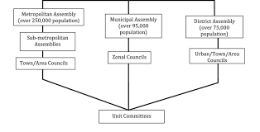  - The District Chief Executive  - District Executive Committee  - The District coordinating Director. | Exercise;  - State 3 bodies under the structure of Government at the district level.  - Write the functions of the 3 bodies mentioned in question 1.
FRIDAY  9:15AM – 10:25AM  70mins | Topic:  Government and Society  Sub-Topic  The structure of Government at the regional and national level. | Objectives  By the end of the lesson, pupils will be able to;  Describe the structure of government at the regional and national level in Ghana  R.P.K  Pupils have already been taught the structure of government at the district level. | Introduction.  Review Pupils knowledge on the previous lesson.  Activities;  - Discuss the structure of government at the regional and national level.  - Assist Pupils to draw the structure of Government at the regional and national level.  - Learners in small groups to discuss the roles of the bodies under the regional and national structure of government.  Conclusion  Reflect on the sequential arrangement of bodies under the regional and national structure of Government in order of Power. |  | 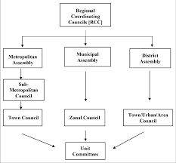  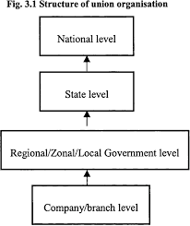 | Remarks

Name of Teacher: School: District:

